Tia Deb
FIQWS
Mr. Metenko
Junk Food
Have you ever had rough days where the only thing liberating your mind is your cake slice sitting in your fridge? Or what about when you launch the McDonalds app to be flooded with several deals, making you get something because of its tempting deals and cheap prices? If that’s the case, then you are drawn in to junk food the same way most Americans are since it is what Americans find convenient because it doesn’t require a significant amount of time in order to be prepared. Commonly referred to as fast food, junk food products contain insignificant nutrition value that typically require little to no preparation. We pass by enormous amounts of fast food chains and most of us end up consuming it frequently in order to get us through the day.
There is one side where some believe it is a derogatory term for food because of how it can eventually harm you if eaten consistently, while the other viewpoint believe the idea of junk food serves a great service because it is suitable to people’s limited time and money. People who have hectic schedules don’t have the time to prepare heavy meals packed with the entailed nutrients your body requires everyday, so resorting to junk food makes it easy to satisfy their cravings quickly and at a lower cost. Consuming moderate amounts of junk food cause no harm as long as it doesn’t exceed the daily required limit of fat and salt, but others find junk food problematic because of the severe health risks when having too much of it. The consumption of too much junk food can put you at risks for obesity, cardiovascular and kidney disease because it is heavily incorporated with sodium, trans fats, saturated fats, and artificial ingredients. Therefore, it becomes very controversial when concluding if junk food is beneficial after all.
Tracey Roizman, a researcher who specializes in the study of nutritional food, focuses on health risks when consuming too much junk food. She uses data from a study published in the American Journal of Clinical Nutrition in 2015 to support her standpoint of how junk food can lead to depression. Researchers show how a high intake of added sugar and refined grains could be a risk factor of nutrition deficiencies that can eventually lead to depression (Roizman, 2).
The article goes on to explain additional disadvantages from junk food, some of which being diabetes, obesity, and heart disease. Diabetes is formed when gaining high insulin levels, resulting in a condition known as insulin resistance. This leads to obesity as individuals who continue eat junk food as a regular part of their diet lack proper insulin level and nutrition. (Roizman, 3). Junk food plays a major role in the obesity epidemic. According to researchers at Harvard University, the obesity rate is expected to reach to forty two percent in the next thirty years. Obesity is a major problem because it exposes you to several other chronic health conditions, commonly being hypertension or heart disease. High intakes of junk food that include a significant amount of sodium can lead to heart disease as sodium consumption increases blood pressure, causing the body to detain onto excess water since salt works on your kidneys. The excess amount of fluid being held causes swelling throughout the body, resulting in poor heart function initially due to the extra stored water. (Shmerling, 1). Concluding Tracey’s negative outlook on junk food, she believes junk food is harmful to one’s overall health since it contains excessive amounts of fat and salt, two substances that relate to one another as it can cause heart disease and obesity.
Producers and consumers both benefit from fast food chains. Bryan Lufkin, a writer of BBC Capital believes that producers profit tremendously in revenue by consumers as fast food places are emerging with many deals, placing products at a minimal value. Financial analysts reported McDonalds line-up of the one, two, three dollar menu heavily increased consumer rate, as well as Wendy’s, incorporating twenty items on the menu for one dollar each. (Lufkin, 5). These fast food industries follow the tactic of stealing customers away from other food chains which promotes the demand of its products. The high demand in products come from consumers who are tempted into this business tactic. Because of these deals in pricing, not only are they buying from these fast food restaurants, but they are buying it consistently. The BBG Good Food Nation found that one in six people eat fast food twice a day. Research shows how thirty-two percent of consumers aged sixteen to twenty-one eat fast food meat at least three times a day. Overall, the low pricing implemented on fast food products attracts younger consumer, relating back to the point how this forms unhealthy habits at a young age, putting them at higher risk to health diseases.
Figure 1 show why consumers prefer fast food places such as McDonalds or Burger King since it is cheap and easy to obtain. Figure 2 points out the calories and different types of fat from popular food menu items, bringing the attention of the high percentage of fat content incorporated in select junk food products. Figure 1 and 2 both relate as they broadcast the message of how affordable it is advertised to be, but also show how deteriorating it can be by consuming it. Figure 1 shows how one meal from KFC, a popular fast food restaurant, takes up from sixty to seventy percent of calories required per day. The food being priced at a low cost allows easy accessibility, leading to frequent consumption of junk food. Revealing the high fat contents show how unhealthy it can be, especially to the crowd who rely on fast food almost every day.
Michelle Fisk, publisher of the "Physician and Sports Medicine Journal", uses data from the American Heart Association to assist her position why junk food should not be consumed regularly. She points out that according to American Heart Association, saturated fat and high cholesterol levels put you at risk for heart disease and stroke. (Fisk, 1). These outcomes lead to chronic disease as the excess sodium can raise blood pressure, eventually leading to other health risks such as type two diabetes and obesity. The consumption of junk food that’s high in saturated fat, sodium, and processed ingredients stops your body from creating the neurotransmitter serotonin, which will eventually lead to anxiety, irritability, and depression, and overall making you nutritionally deficient.
However, there are ways junk food can be perceived as beneficial aside from the chronic health conditions. It is argued that if the intake of junk food is occasional or at in small increments, it could not cause you to have high blood pressure, diabetes, or obesity because you wouldn’t be having an excess amount of it. Publisher Amy Ahlberg points out that according to sciencenews.org, in relation to the magazine of the society for science and public, there are natural trans fats in some foods known as conjugated linoleic acid (CLA) that are proven to have anti-cancer characteristics. (Ahlberg, 4). For example, she explains the product Cheese Whiz and how it contains more cancer fighting compounds as opposed to any other normal cheese.
A publisher of ETimes, an article of health news claim that there are certain junk foods that cause minimum harm to the body. The article explains the benefits of dark chocolate, as it contains high amounts of antioxidants and is able to decrease the risk of heart disease. The article goes on to explain how popcorn, baked snacks, and processed cheese can be good for you. Processed cheese contains CLA and is also an effective antioxidant, stating how a recent study revealed that processed cheese contains more CLA than natural cheese, an example being cheddar. Overall, this article attempts to defend and point out some junk food products that don’t cause health risks the way the opposing viewpoint claims they do.
Others still argue the overall disadvantages when getting involved with junk food. Some argue that starting
In summation, junk food prolongs to be a controversial topic. Although it imposes health risks, we come in contact with it almost every day of our lives. Junk food makes it convenient for people who have busy schedules that don’t have the time to prepare heavy and healthy meals. Relying on junk food makes it easy for the ones who are busy to satisfy their cravings while served fast. However, the serious health risks being obesity, heart disease, and even depression can make you contemplate if something with those results is worth getting for due to the convenience of one’s time. Considering all the possible outcomes, it’s important to ask yourself if it really is convenient overall.

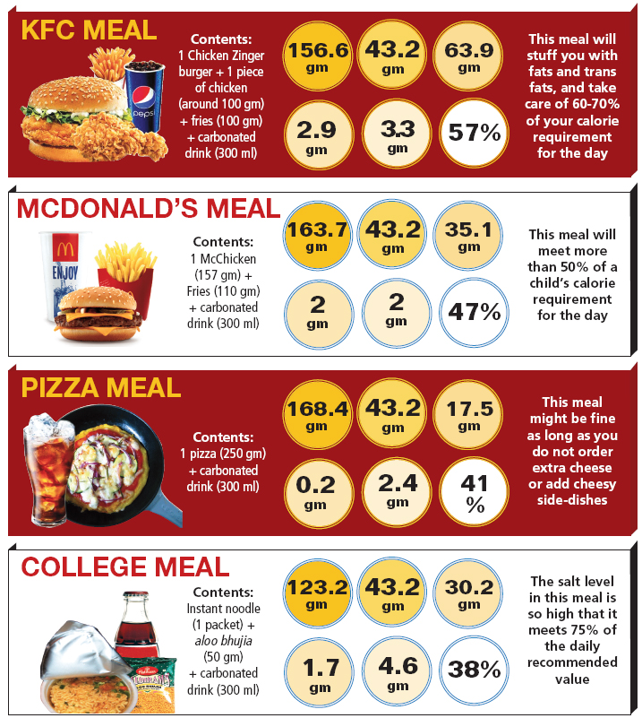
(Fig. 1) Various popular fast food places and items with its fat content
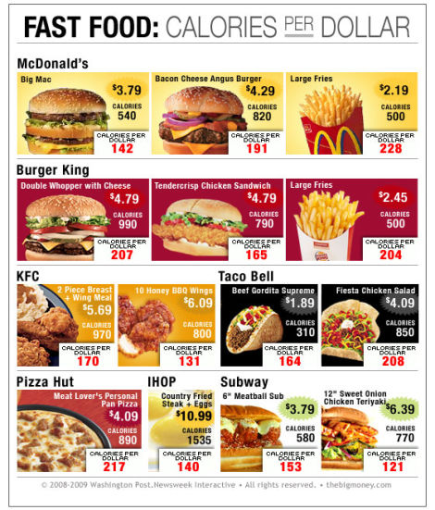
(Fig 2) Popular fast food items and its cheap prices

